Sayim Khan

CO3015 Computer Science Project

Plan

Games with Smartphones

10/2017 (Plan Submission)

Department of Informatics, University of Leicester

Contents

Introduction: 2

Project Objectives: 2

Functional Requirements: 3

Project Forecast (Semester 1): 5

Project Forecast (Semester 2): ………………………………………………………………………………………………………….6

# Introduction:

My aim is to create my own Android smartphone game using a modern Game Engine which are used widely in nearly every form of game development ranging from Indie games to large Triple A game titles. I want the game to be able to take full advantage of its mobile platform, by have gameplay elements that would utilize smartphone features such as the touch and accelerometer inputs. I finally want the game to have a unique story that I craft by myself, which also have interesting characters, as well as having unique and interesting gameplay features such as hand-crafted puzzles and combat.

# Project Objectives:

My primary objective and challenge is to create and complete 8 – 10 game levels. These levels can be thought of being floors of a building and the overall objective is 7 – 10 levels. Completion of each floor will mean that designing of the level (unique theme, atmosphere model and texture placement, etc), lighting and shadows, sound, story dialogue system, gameplay mechanics are completed and polished, this can be considered a milestone and determining overall progress because each floor can be considered a 10-15% of the project, because when all the floors are 100% completed, the game will be completed.

My second objective is to create a unique story for the game that will be told over the course of the levels with custom characters that have personalities that I create. This will be very challenging as I will have to write the bio and personality traits for each character, which I have never done before. I will also have to learn to design and model each character, so that they have their own unique appearance via 3D Modelling solutions such as Blend or Maya LT, which I have never used or tried 3D Modelling, so learning this and trying to design the characters will be another challenge. I hope to make 4 unique character that are heavily involved in the story.

My third objective is to create several RPG style gameplay features required for this project, these include but are not limited to:

* Dialogue System: This will be the primary way of allowing the game to communicate with the player as well as telling the story. For this system, I will have to figure out and design a way of storing and using story text as well as NPC text. I will also have to figure out the best way of presenting the dialogue to the player, through traditional text boxes or Visual Novel system dialogue with textboxes, options and NPC Portraits.
* Inventory System: This will allow the player to store and use items though out the game, I will have to design the interaction, storage and UI for the inventory system. My challenge is to find a way of making the inventory system intuitive and integral to the gameplay.
* Statistics, Levels and Experience: I will have design and implement a level and experience system, which will allow player to level up and increase character statistics, this will also allow player to take on more powerful enemies, but add an element of progression that will help make the gameplay more fulfilling and rewarding. My challenge is how to calculate how much experience will be required for the next level and how much experience defeated enemies will give the player, as well as trying to predict player level at the start of each floor.
* Combat System: This gameplay feature will allow the player to find and fight hostile NPCs that will attempt to block the player’s way and attack them. I will have to design and implement the system to do character statistics based combat. For example, if the player has a certain about of ‘Attack Power’, this will affect enemies with different amount of ‘Defence Power’ differently such as less or more damage. My challenge will be that I will have to figure out how to calculate this, as well as how this would be affected by other factors such as bonus damage from weapons and armour. I will have to also think about how and how many enemies will spawn at locations.

These are my main objective and challenges that I will have to find and make solutions to overcome. By overcoming theses, it will bring me closer to building my ideal game.

# Functional Requirements:

Movement and Navigation:

As a player…

* I must be able to open a menu by clicking a button on screen, so I have access to more options such as save, load, etc
* I must be able to save my progress, so that I can continue later with all my progress intact
* I must be able to load my progress, so that I can continue with my prior save.

Dialogue System:

As a player…

* I must be able to touch a non-hostile NPC on screen, I must be able to interact with them.
* I must be able to interact with a non-hostile NPC, I must be able to see on-screen what is being said by that particular NPC.
* I must be able to see that text is displayed in a ‘floating’ text box.
* I must be able to see the NPCs name above the text box so that I know what the name of the NPC that I am speaking to is called.
* I must be able to click on a button that says ‘Continue’, and the next lines of text must replace the current text in the text box, after reading the current text, so that I can proceed with the conversion.
* I must have access to a ‘finish’ button that will end the conversation and will remove the dialogue box from the screen, so I can continue to play the game.

Inventory System and items:

As a player…

* I must be able to find treasure chest scattered on the game levels, so that I can have access to new items and have a sense of accomplishment.
* I must be able to find different type of item in treasure chests that I find on the game level.
* I must be able to interact and open the chests that I find in the game level, so I can have access to the items that I find.
* I must be able to obtain and store the item from the opened chest, so that I can have use them on my character immediately or for use later on.
* I must be able to find healing items in certain chests, so I have a way of restoring the health of my character.
* I must be able to see that different weapons have different stat bonuses that affect my characters stats, so that my character can increased stats and that weapons are useful.
* I must be able to see that different weapons have different stat bonuses that affect my characters stats, so that my character can increased stats and that weapons are useful.
* I must be able to see that different armour have different stat bonuses that affect my characters stats, so that my character can increased stats and that armours are useful.
* I must be able to find swords in certain chests, so I have a way of increasing my characters stats by using bonus stats.
* I must be able to find armour in certain chests, so I have a way of increasing my characters stats by using bonus stats.
* I must be able to access my inventory by touching a button on the menu screen.
* I must be able to see the items, weapons, amour in my inventory on screen, so that I know what I have available in my inventory for my character to use.
* I must be able to see what weapon and amour my character has equipped, so I know what they are currently using and know how it will affect my character.
* I must be able to touch on a healing item in my inventory and have an option to use the item on my character, so that I can restore my characters health.
* I must be able to touch on a sword in my inventory and have an option to equip the weapon, so that I can change my characters currently equipped weapon and have different stat bonuses.
* I must be able to touch on a piece of armour in my inventory and have an option to equip the weapon, so that I can change my characters currently equipped weapon and have different stat bonuses.
* I must be able to see the total size of my inventory and how much of it is in use currently, so I know exactly how full my inventory is
* I must be able to remove/drop an item, so that I have more space for new items in my inventory.

Enemies and Combat System:

As a player…

* I must be able to attack a hostile NPC, so that I can gain experience and level up.
* I must be able to view the hostile NPCs, so I know what level the enemy is and if they are lower or higher level than my character.

Levels, Statistics and Experience:

As a player…

* I must be able to access the level screen when I click on a button in the menu
* I must be able to see my character level in a dedicated stat and level screen, so that I know exactly what level my character is.
* I must be able to see on the level screen a display of how much Experience Points I have remaining until I ‘Level Up’, so that I know roughly how much more experience I have to gain before levelling up.
* I must be able to gain stat points when I level up that will contribute to my characters stats, so that my character can get stronger in the game.
* I must be able to allocate stat points to stats of my choice, so that I can change my characters stats to my liking.
* I must be able to see my characters number stats on the level screen, so that I know what the stats of my character are.
* I must be able to see a numerical change in my characters level, when he levels up, so that I know that my character has gained a level.
* I must see a numerical change to my characters stats on the level screen when he levels up, so that I can see the numerical benefit of levelling up.

# Project Forecast (Gantt Chart):

Semester 1:

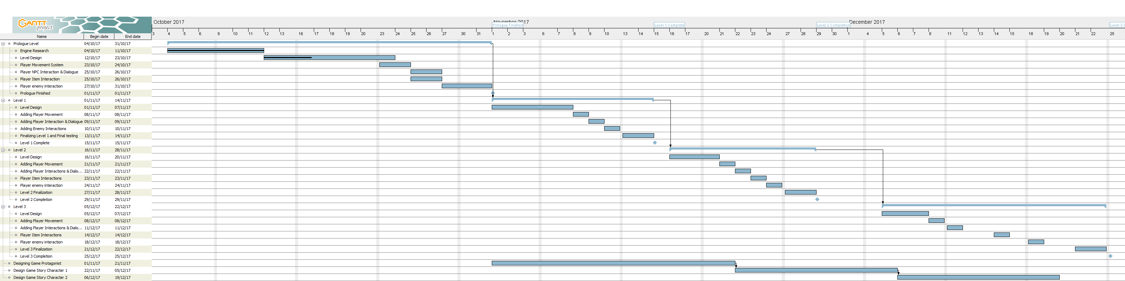



Forecast Explanation:

The main reason why I anticipate that this is about right is that as I create more levels and have the main systems, like combat and levelling in place because of prior level, there will just be adding existing scripts to new objects on new levels and the more levels that I create, the more familiar and comfortable I will become with the Unity suite and level creating on a whole, that’s why I feel after 2 levels I will start character modelling, so I can start learning that. I hope to get 2 levels and 2 characters done by the prototype stage.

**Milestones are level completion, they are specified by the blue-ish diamond**

Semester 2:

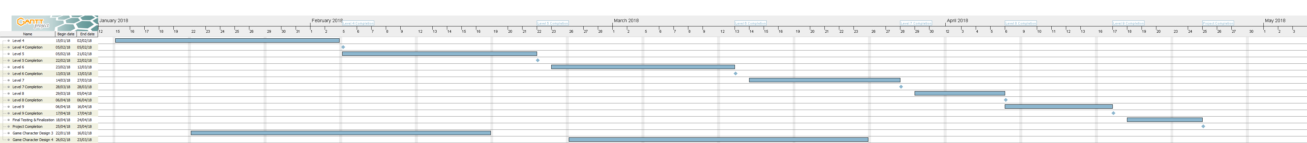





Forecast Explanation:

This is my rough estimate for the last 7 levels. As anticipated 10 levels will be quite a rush and a squeeze, so ill opt for 9 levels instead and have longer for finalizing and testing, with 7 days spare if anything happens. The expectations for level complete length might be a tad longer than how much it may really take, because I assume I’ll be pretty confident with the tools at this point, but having a little leeway could be useful on a rainy day.